February 2020

Dear parents, guardians and carers,

Hope this letter finds you well. Just a few words about The Friends of West Newcastle Academy.

The Friends is a group of parents and teachers that exists to support the school in providing extra equipment and stimulating experiences which will benefit all our children.

We are delighted to announce that following the AGM in December, a committee has been formed as below:

Fungying Koshy  (Chair) | Paul Dewhurst  (Vice Chair / Social Media Administration) | Sean Hudson  (Social Media Administration)

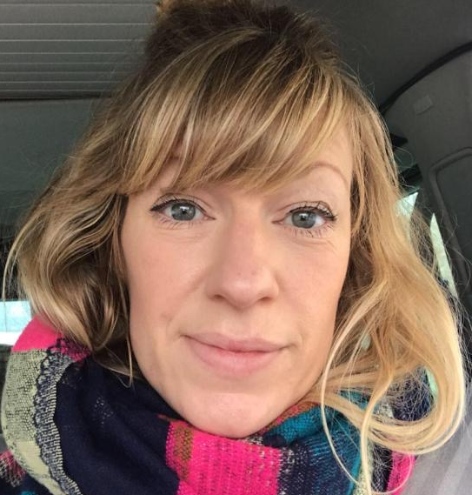 |  |  | Denisa Conkova  (Secretary)
Victoria Brook  (Treasurer) | Amanda Cavanagh  (Treasurer) | Zara Bachvarova  (Secretary)

The committee, together with a brilliant team of active members, are ready to:
- Put on activities and events that are fun and beneficial to our children and parents;
- Bring the school community together;
- Raise funds from charitable organisations.

Recently The Friends have planted trees on the school site, organised a Nature Park scavenger hunt and put up lanterns to celebrate Chinese New Year.

On Shrove Tuesday (25th February) we will be giving out pancakes to pupils and collecting donations to fund some playground markings for games.

It is important to keep you (parents / guardians / carers - all Friends!) up to date with events and activities! You are very welcome to get involved in any of them by helping if you can.

We are inviting everyone to join the new Facebook group. It is a closed group. Just search ‘Friends of West Newcastle Academy’ and send a friend’s request.

We will also be holding a coffee morning next Tuesday 11th of February at the main school building after drop off.

Would love to meet you all on The Friends’ Facebook group and at the coffee morning. If you have any questions, feel free to chat to any of us during school runs or to message us on Facebook.

Yours sincerely,

The Friends of West Newcastle Academy

