Chester’s Fairground Activities

Task 1:
Can you design a front cover for the book ‘Chester’s Fairground’? – Think about what the title makes you think of, what do you think the book will be about? Who is Chester?

Task 2:
Read the books blurb –
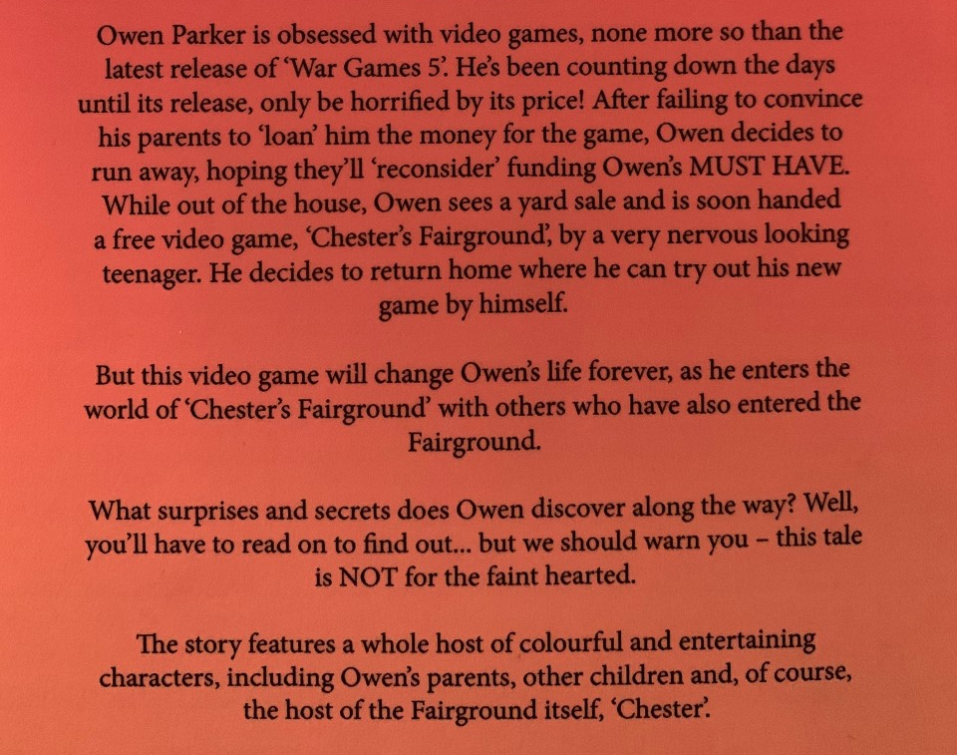

Can you write a few sentences explaining what you think might happen to Owen?
______________________________________________________________________________________________________________________________________________________________________________________________________________________________________________________________________________________________________________________________________________________________
Task 3:
Meet the characters –
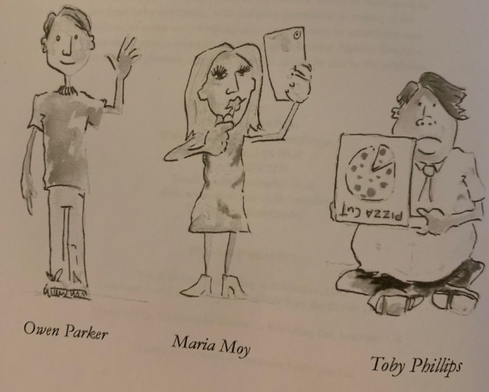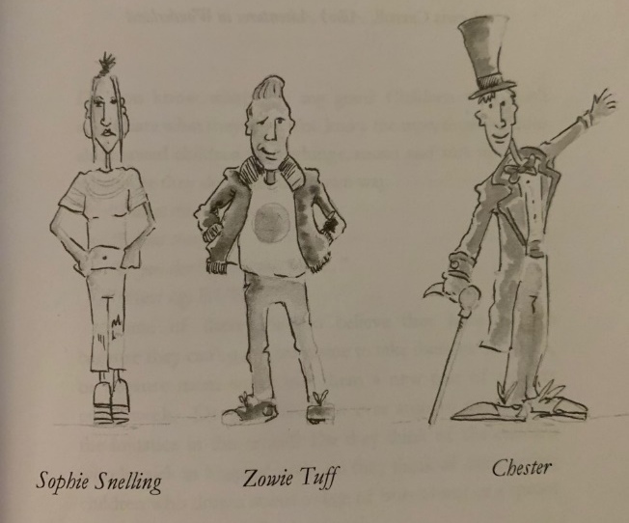

Based on the look/names of the characters, can you write what you think their personalities will be like?

Owen Parker - ____________________________________________________________________________________________________
Maria Moy - ____________________________________________________________________________________________________
Toby Phillips - ____________________________________________________________________________________________________
Sophie Snelling - ____________________________________________________________________________________________________
Zowie Tuff - ____________________________________________________________________________________________________
Chester - ____________________________________________________________________________________________________

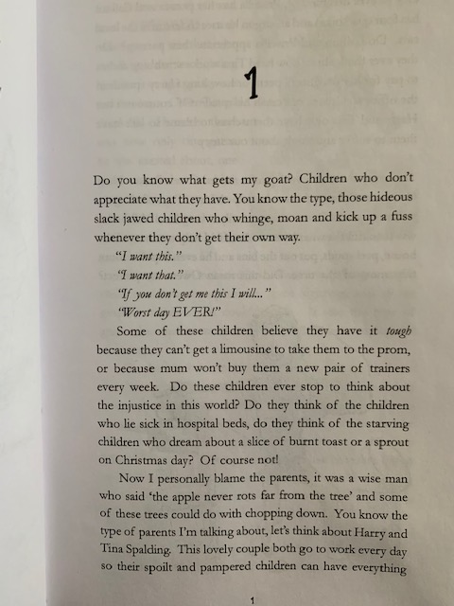
Chapter 1
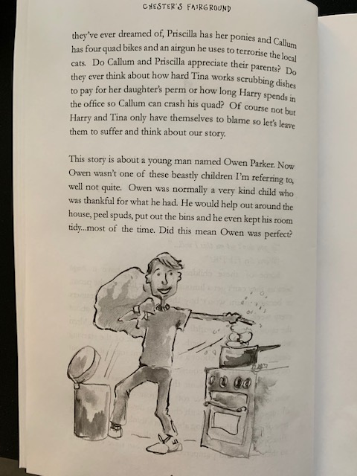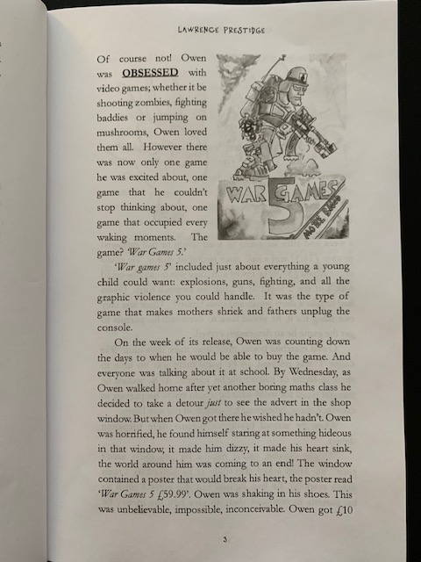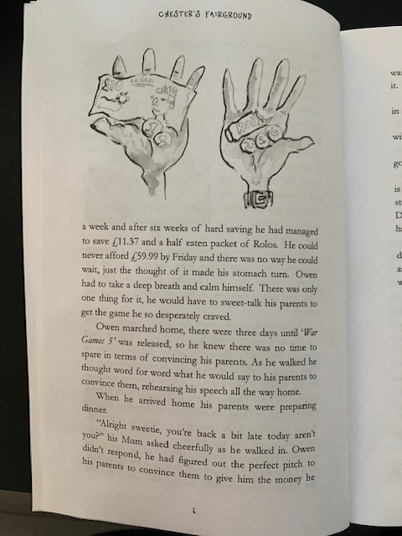
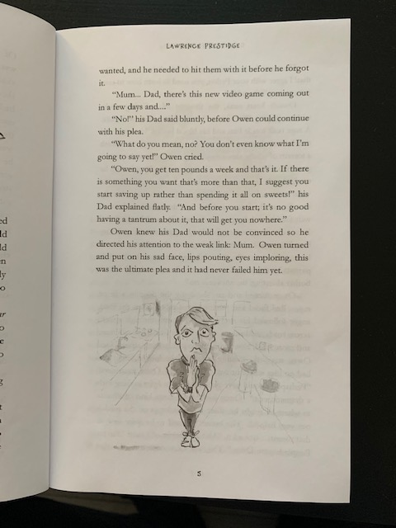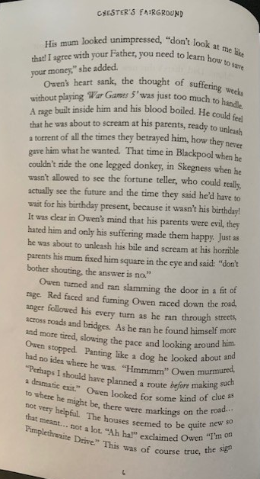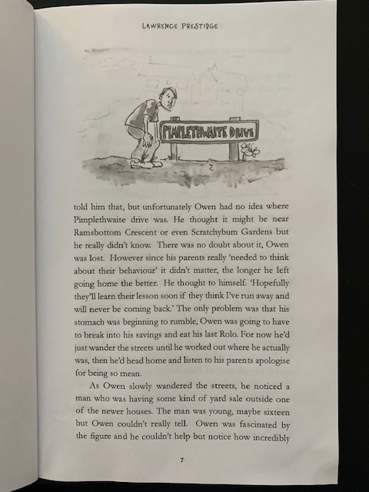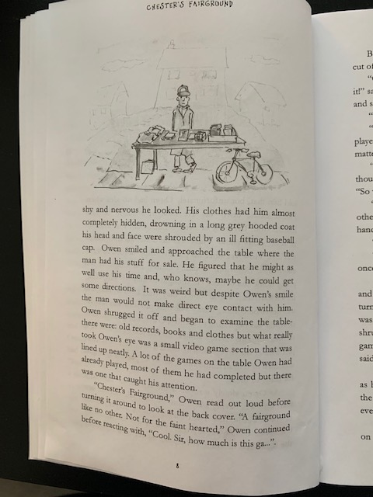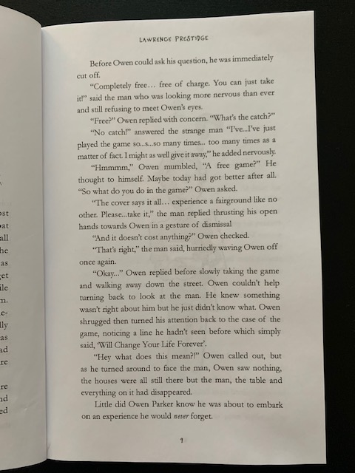
Chapter 1 – Questions

- Why do you think the author uses so many questions in his writing? What do you think this achieves?

- What is the name of the game Owen wants to buy?

- How much does the game cost and how much money does Owen have?

3.b. How much more money does Owen need in order to buy the game?

- Choose a phrase which best describes how Owen reacted when his parent’s said no to buying him the game;
He was polite and understanding.
He was angry and wanted to scream.
He was calm and happy.

- Can you find 3 reasons why Owen thought his parent’s hated him?

- Where did Owen end up when he ran away from home?

- Why do you think the man having the yard sale looked nervous and shifty?

- Describe how Owen was feeling/thinking from the picture below.

